|  |  |  |
| --- | --- | --- |
|  | | |
|  | | |
| **Bullseye with solid fillPurpose**  To guide users in completing the case management referral in Jiva | **Effective Date:** | 10/7/24 |
| **Approved by:** | Tapinder Dhillon |
| **Department:** | Case Management |
| **Tools with solid fillYou’ll need:**  Access to Jiva provider portal | **Revision Number:** | Ver. 1 |
|  | |

|  |  |  |
| --- | --- | --- |
| **Revision Date** | **Change Description** | **Author** |
| [Enter a date] |  |  |
|  |  |  |

|  |
| --- |
|  |

1. Locate member to be referred: Click “Menu” and then select “New Request”

1. Add Member ID and select “Search”

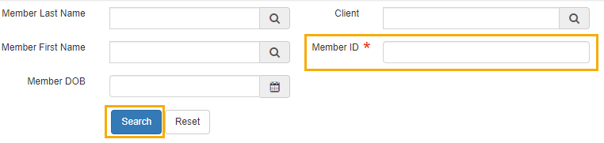

1. A screenshot of a computer

   Description automatically generatedClick “Add Request” drop down (right side of the screen) and select “Case Management”
2. If the following message appears when you click “Case Management” – Select “Ok”

1. Complete Episode Details:

**Episode Status:** Referral

**Source:** Select appropriate source. For example: Provider, Physician on behalf of Member, Contract Physician/Provider

**Reason for Request:** Case management/Coordination of care or Pregnancy education

**Please do not edit the acuity from “0”**

**Leave Member class, Episode class, Severity and complexity type fields BLANK**

1. Please **“Do not add”** Program Name and Program Open reason

1. Add diagnosis if available

1. Complete “Notes” section:

**Note Type:** Provider Portal

**Notes:** Add “Detailed Reason for Referral” Under “Notes” tab

1. Click Save and Continue



1. The Episode/Referal is now created

